Task 2: ResNet-18 from Scratch on GTSRB
Student Information
Name: Raghavam Gupta
Branch: Mechanical
Assignment: Week 3 – Convolutional Neural Networks
Roll NO.: 25135119
AI Assistance
Artificial Intelligence tools were used as learning aids during this assignment. AI assistance was utilized primarily for debugging code, report making, clarifying implementation details, and improving documentation.

Objective
The objective of this task was to implement the ResNet-18 architecture from scratch using PyTorch and train it on the German Traffic Sign Recognition Benchmark (GTSRB) dataset. Unlike Task 0, where a custom CNN was designed, this task focused on reproducing the residual learning framework proposed in the original ResNet paper.
The goal was to understand how residual connections help train deeper neural networks efficiently while achieving high classification accuracy.

Dataset
The German Traffic Sign Recognition Benchmark (GTSRB) dataset was used.
Dataset Characteristics
- Number of classes: 43
- Total images: 39,209
- Image size after preprocessing: 32 × 32 pixels
- Color channels: RGB
Data Preprocessing
The following preprocessing steps were applied:
- Image resizing to a fixed resolution.
- Conversion of images to tensors.
- Normalization of pixel values.
- Dataset split into training and validation sets.
Dataset Split
Dataset | Samples
Training | 31,367
Validation | 7,842

ResNet-18 Architecture
The ResNet-18 model was implemented completely from scratch without using any pre-built torchvision models.
Initial Convolution Layer
- Convolution: 3 → 64 channels
- Kernel size: 3 × 3
- Stride: 1
- Padding: 1
- Batch Normalization
- ReLU Activation
Residual Blocks
The network contains four stages:
Layer | Output Channels | Residual Blocks
Layer 1 | 64 | 2
Layer 2 | 128 | 2
Layer 3 | 256 | 2
Layer 4 | 512 | 2
Each residual block consists of:
- Convolution Layer
- Batch Normalization
- ReLU Activation
- Convolution Layer
- Batch Normalization
- Residual Skip Connection
Classification Head
- Adaptive Average Pooling
- Fully Connected Layer
- Output Size = 43 Classes

Training Configuration
Parameter | Value
Optimizer | Adam
Loss Function | CrossEntropyLoss
Batch Size | 64
Epochs | 5
Learning Rate | 0.001

Training Results
Loss History
Epoch | Training Loss | Validation Loss
1 | 1.2439 | 0.1087
2 | 0.0702 | 0.0972
3 | 0.0382 | 0.0829
4 | 0.0325 | 0.0197
5 | 0.0175 | 0.0153
The training loss decreased rapidly during the first few epochs, indicating effective learning. Validation loss also decreased consistently, suggesting good generalization and minimal overfitting.

Validation Accuracy
Final Validation Accuracy:
99.55%
This result demonstrates that the ResNet-18 architecture successfully learned discriminative features from traffic sign images and achieved excellent classification performance.

Analysis
Several observations were made during training:
- Residual connections enabled stable optimization of a deeper network.
- Training converged quickly despite the increased depth compared to the custom CNN.
- Validation loss closely followed training loss, indicating strong generalization.
- ResNet-18 achieved slightly higher performance than the custom CNN while maintaining stable training dynamics.
- Skip connections helped preserve information across layers and mitigated vanishing gradient issues.
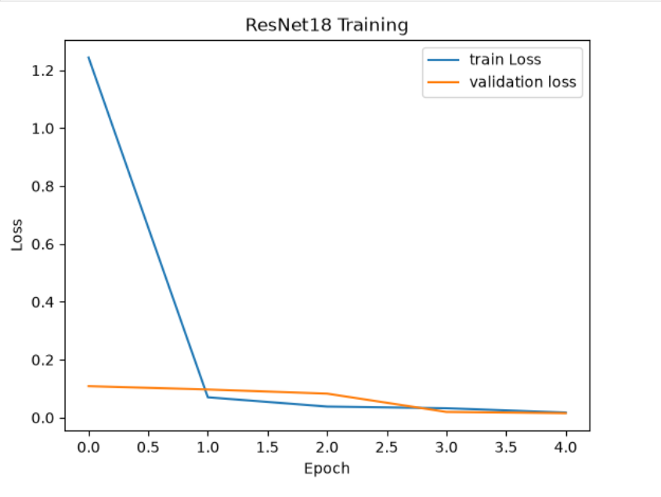

Confusion Matrix
A confusion matrix was generated after training to evaluate class-wise performance.
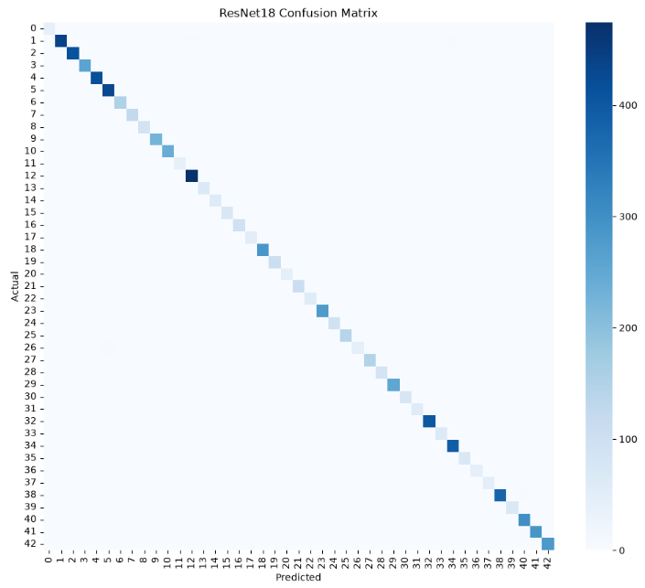
The matrix showed that most samples were correctly classified along the diagonal, indicating strong performance across nearly all traffic sign categories.

Sample Predictions
Several validation images were tested after training.
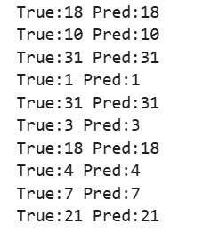
The predicted classes matched the true labels for the majority of samples, confirming the effectiveness of the trained model.
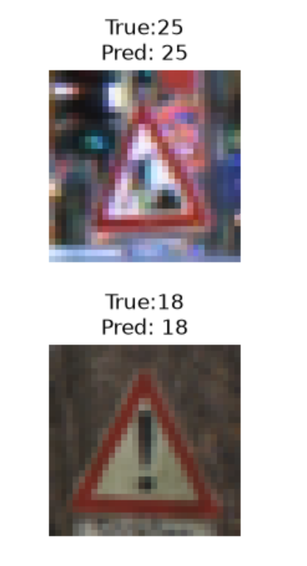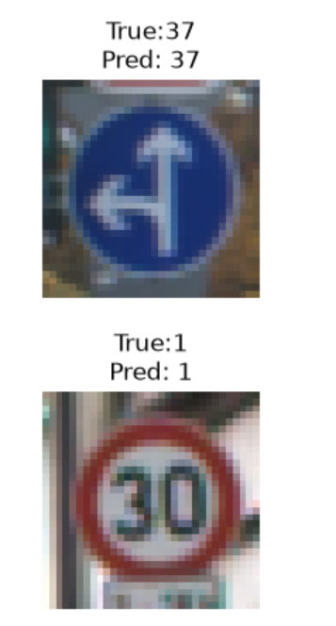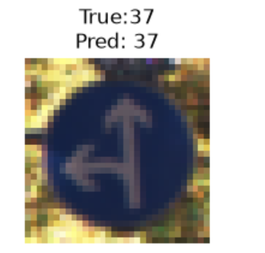
Conclusion
In this task, a complete ResNet-18 architecture was implemented from scratch using PyTorch and trained on the GTSRB dataset. The model achieved a validation accuracy of 99.55% while maintaining low validation loss.
This task provided practical understanding of residual learning, skip connections, deep CNN architectures, and modern image classification techniques. The results demonstrate the effectiveness of ResNet-style networks for traffic sign recognition tasks.

References
- He, K., Zhang, X., Ren, S., and Sun, J. (2016). Deep Residual Learning for Image Recognition.
- PyTorch Documentation.
- German Traffic Sign Recognition Benchmark (GTSRB) Dataset.

